Install foxyproxy for chrome

<https://chrome.google.com/webstore/detail/foxyproxy-standard/gcknhkkoolaabfmlnjonogaaifnjlfnp?hl=en>

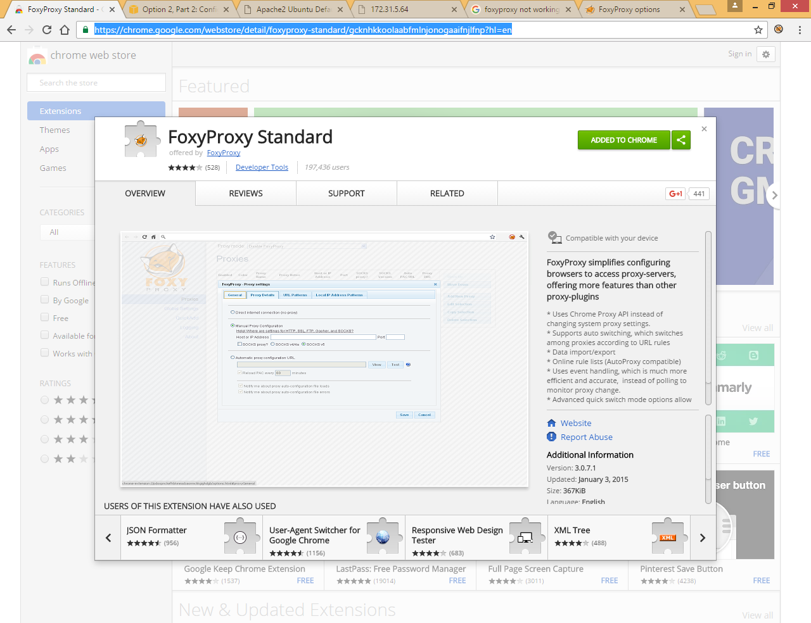

Add to chrome

You will get following icon

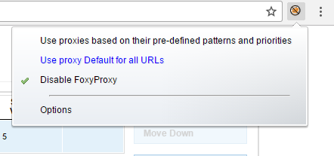

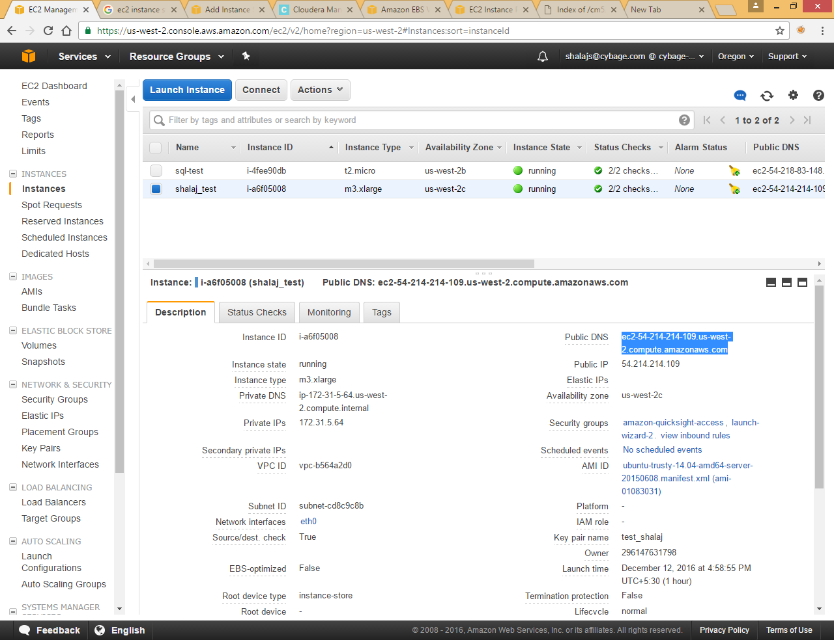

Install http server on machine

sudo apt-get install apache2

access using public dns or public ip

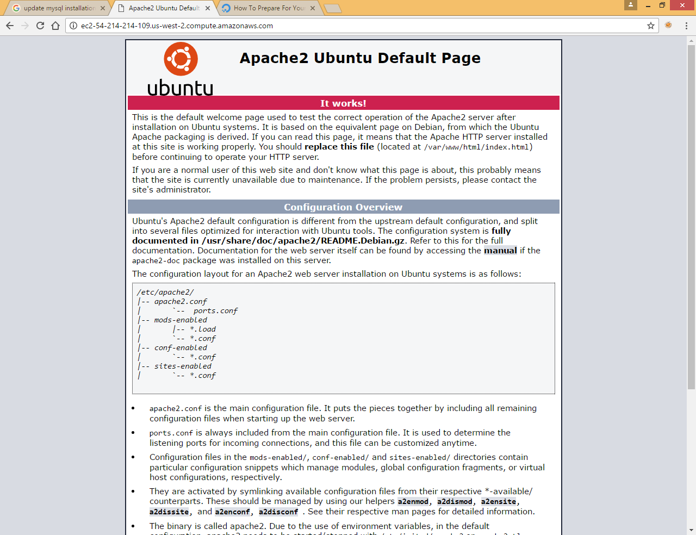

It is accessible

Now try to access same page using private ip

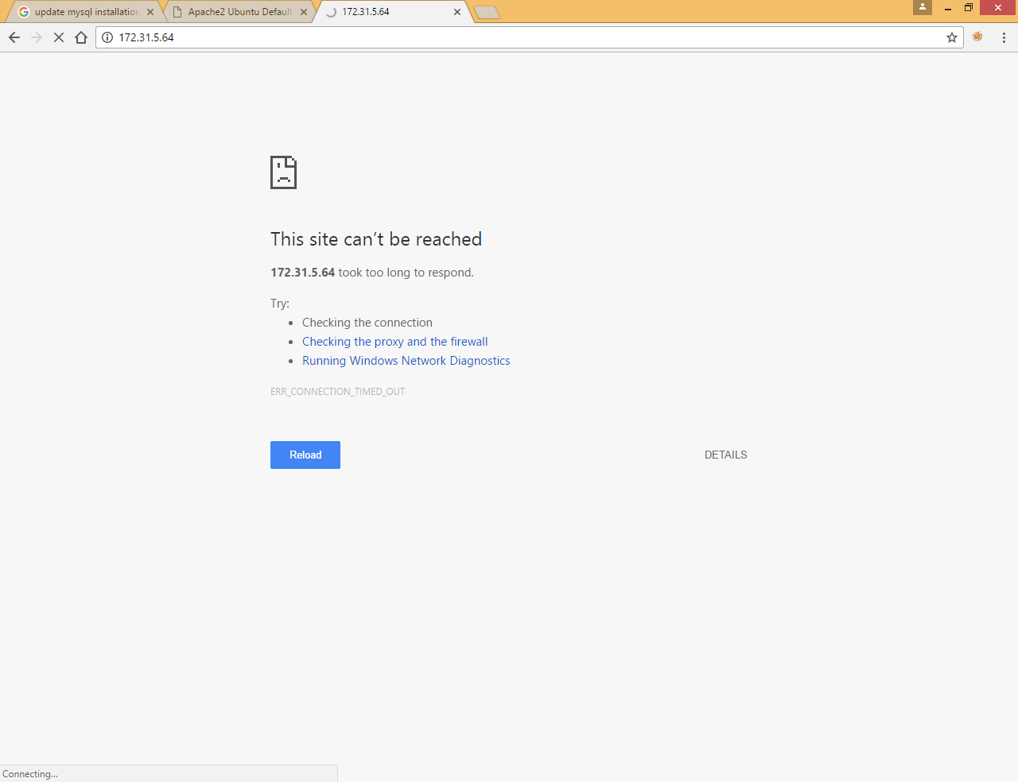

It is not accessbile

Now we are going to use ssh tunneling

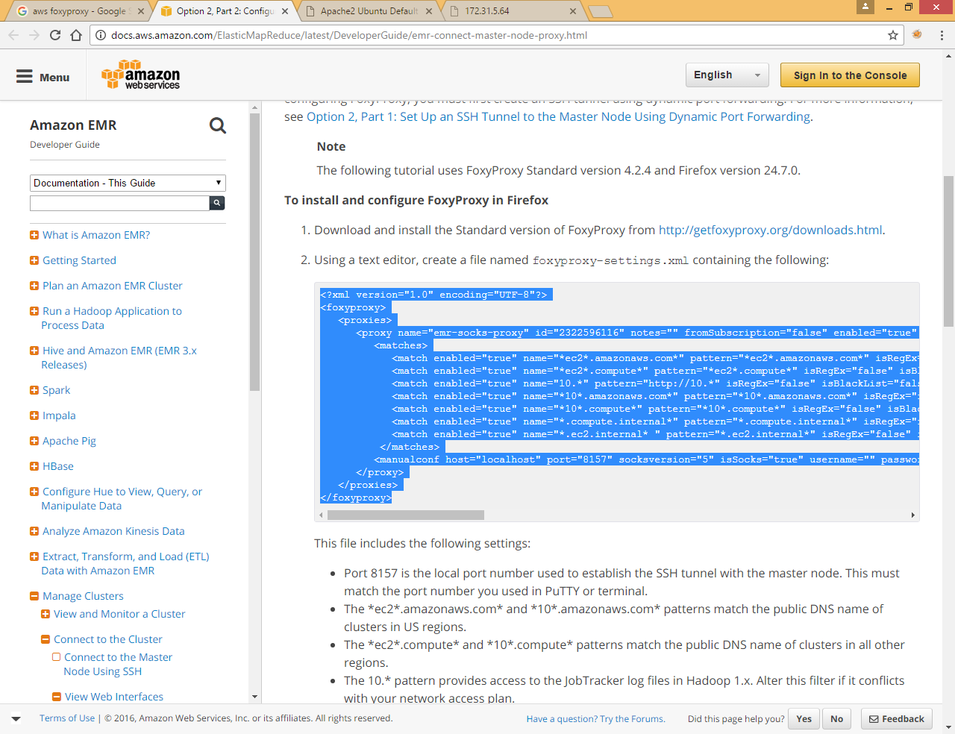

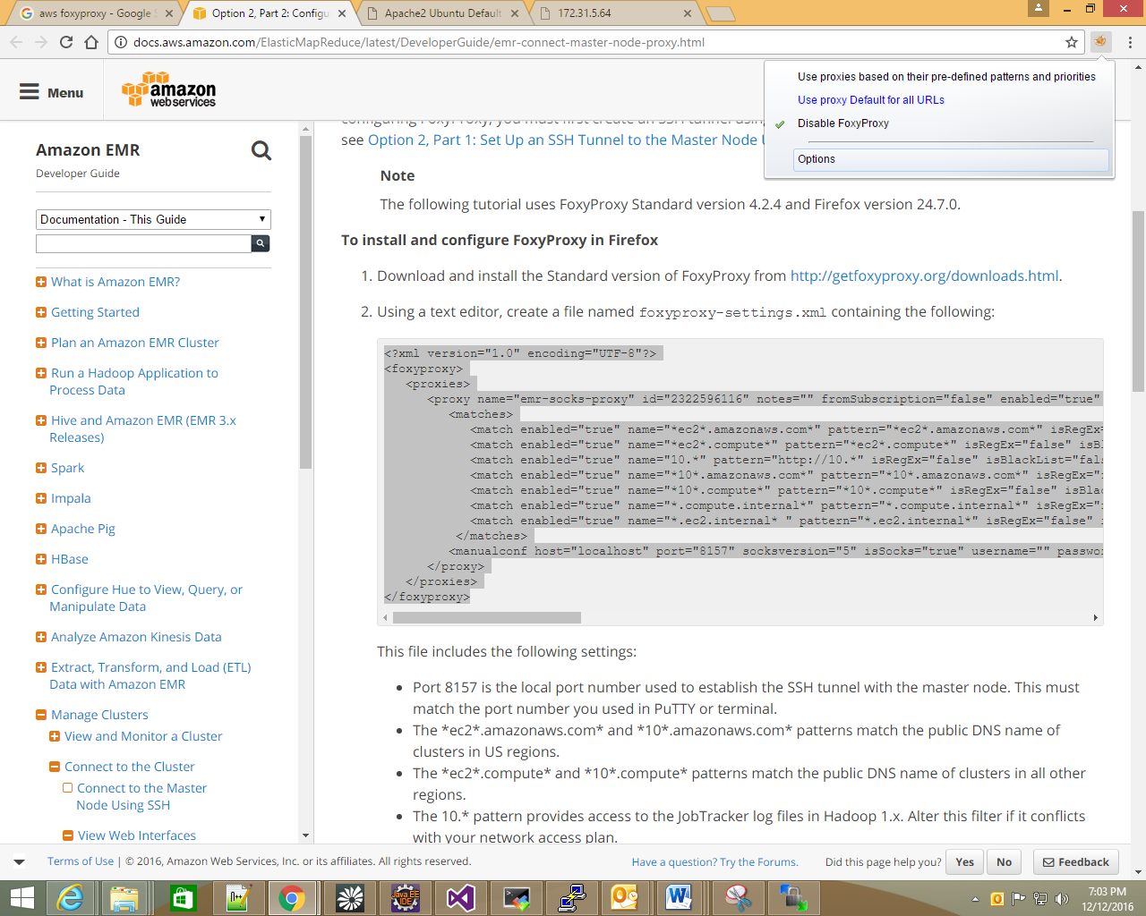

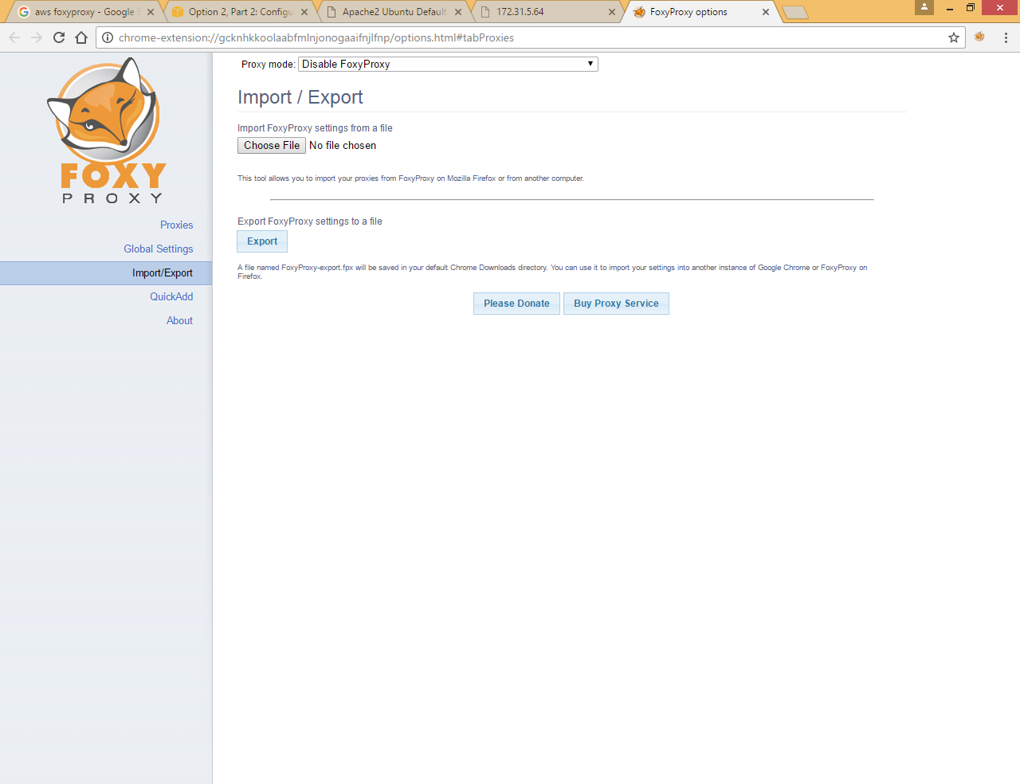

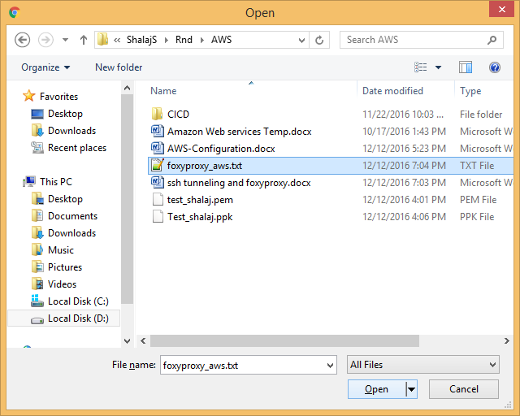

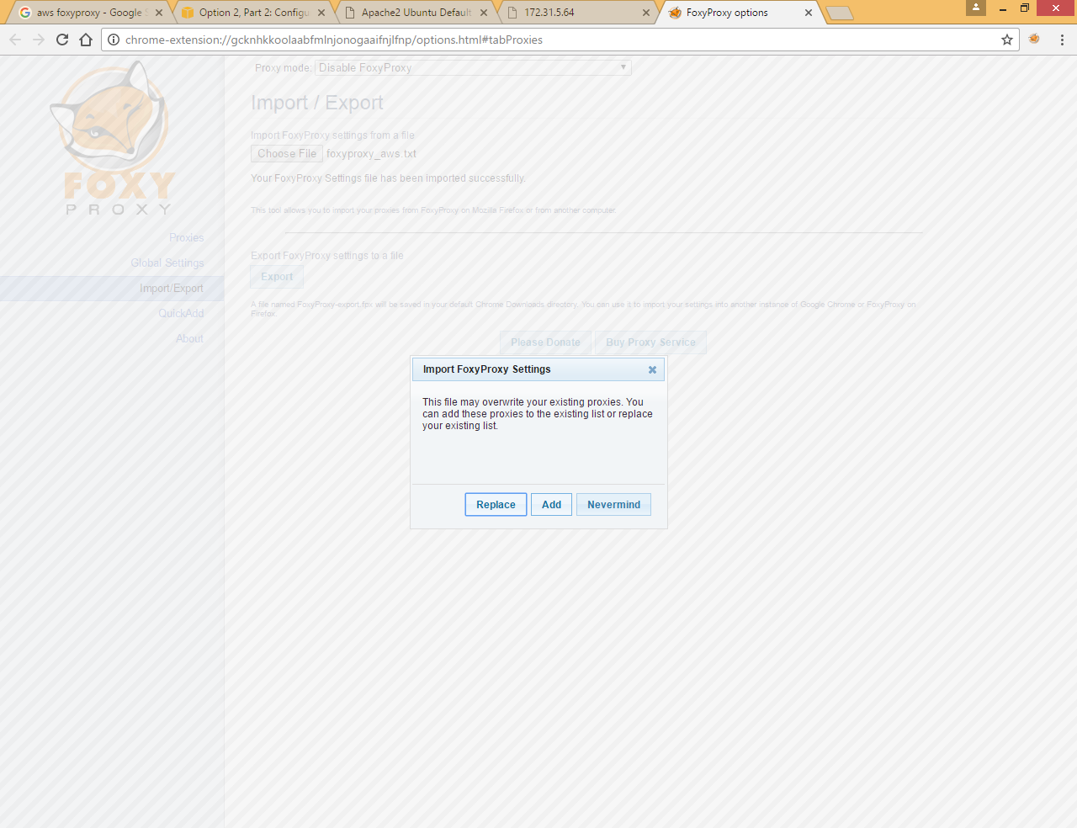

Click Add

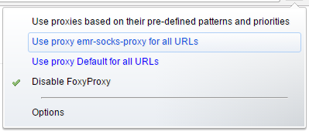

Now run below command in termingal

|  |
| --- |
| ssh -i ~/.ssh/test_shalaj.pem -ND 8157 ubuntu@ec2-54-214-214-109.us-west-2.compute.amazonaws.com |



It will hang



Select second option

Now try the same page with private IP

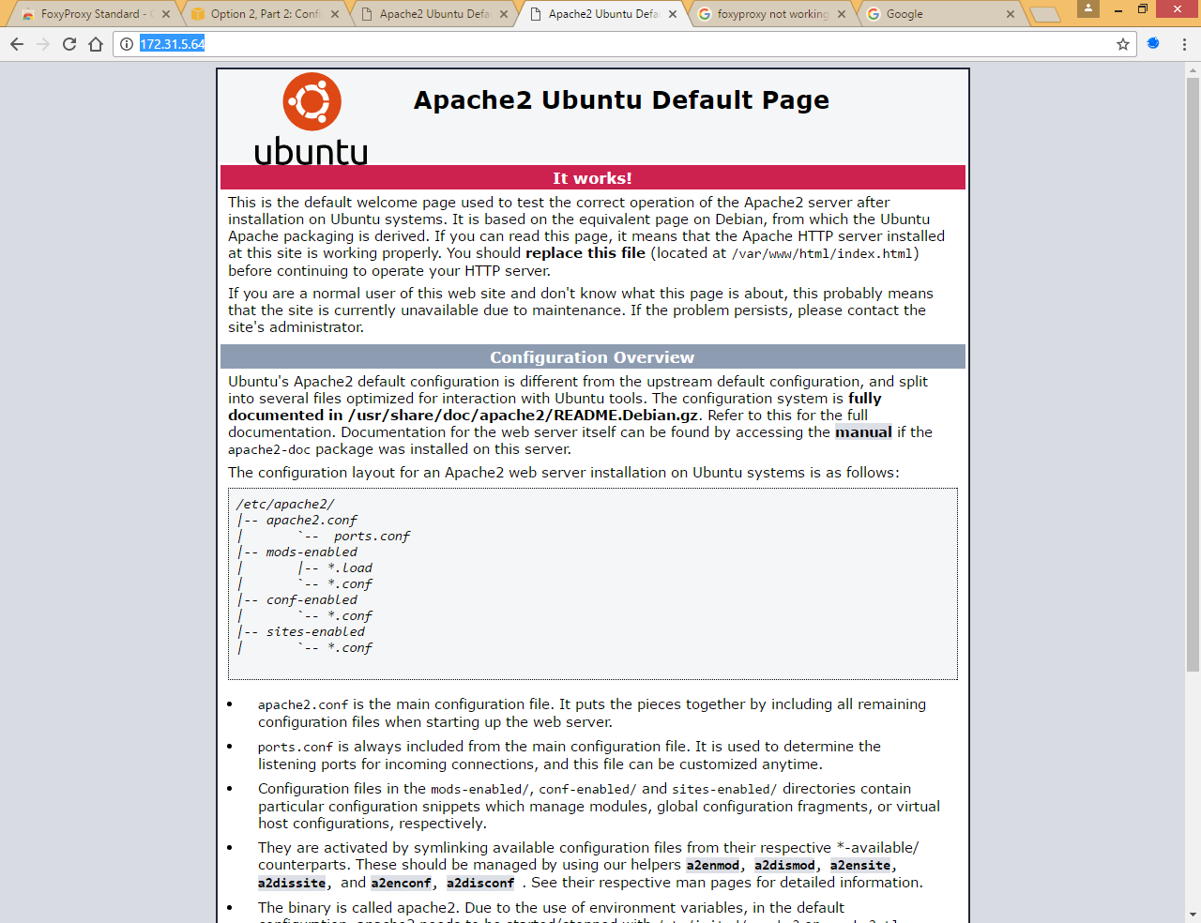

Now it is working fine